**Algorithm/Insights**

The given problem can be solved by using Dynamic Programming as described below:  
1. Create a temporary boolean array validWords[] defined as:  
validWords[i]  
            = true, if input substring from 0 to i forms valid words string  
            = false, otherwise  
2. For i = 0 to input.length,  
   a. If input substring from 0...i is present in the dictionary, then set validWords[i] = true  
   b. If validWords[i] == true, from j = i+1 to n-1, check if substring from i+1 to j, for all values of j (= i+1 to n-1), is present in the dictionary and set validWords[j] to true if found in the dictionary.  
3. When we reach the end of the string, if validWords[n-1] is true, then return true else return false.  
  
Example:  
Consider the dictionary:  
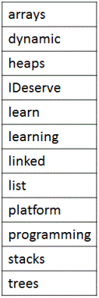  
Input string:  
IDeservelearningplatform  
  
Temporary array validWords[] initialized to false (represented by F in the image).  
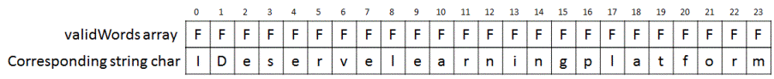  
  
i = 0:  
Is input substring from 0...i (= I) present in the dictionary? ✖  
    
i = 1:  
Is input substring from 0...i (= ID) present in the dictionary? ✖  
  
i = 2:  
Is input substring from 0...i (= IDe) present in the dictionary? ✖  
  
Proceeding till i = 6:  
Is input substring from 0...i (= IDeserv) present in the dictionary? ✖  
  
i = 7:  
Is input substring from 0...i (= IDeserve) present in the dictionary? ✔  
Set validWords[i] = true (represented by T in the image)  
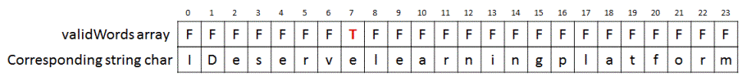  
  
Next, starting from j = i+1 to n-1, on checking for all substrings from i+1 to j, we see that 'learn' (ending at j=12) and 'learning' (ending at 15) form valid dictionary words.  
So we set, validWords[12] = true and validWords[15] = true.  
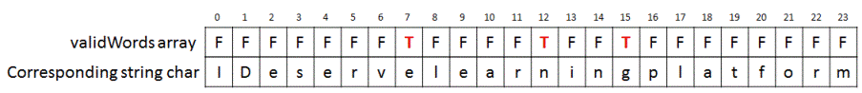  
Since, we have not reached the end of the input string, we proceed with next steps.  
  
i = 8:  
Is input substring from 0...i (= IDeservel) present in the dictionary? ✖  
  
Proceeding till i = 11:  
Is input substring from 0...i (= IDeservelear) present in the dictionary? ✖  
  
i = 12: input substring = IDeservelearn  
validWords[i] is already true.  
Next, starting from j = i+1 to n-1, on checking for all substrings from i+1 to j, we see that there is no valid dictionary word found.  
  
Proceeding like before for i = 13 and 14:  
Is input substring from 0...i (= IDeservelearni) present in the dictionary? ✖  
Is input substring from 0...i (= IDeservelearnin) present in the dictionary? ✖  
  
i = 15: input substring = IDeservelearning  
validWords[i] is already true.  
Next, starting from j = i+1 to n-1, on checking for all substrings from i+1 to j, we see that 'platform' (ending at 23) is a valid dictionary word.  
So, we set validWords[23] = true.  
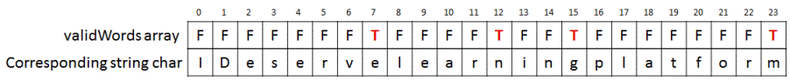  
Since, we have reached end of string and validWords[n-1] = validWords[23] = true, hence we return true.